Memorandum

City of Lawrence

Police Department

To: Diane Stoddard, Interim City Manager

From: Tarik Khatib, Chief of Police

Cc: Casey Toomay, Assistant City Manager

Brandon McGuire, Assistant to the City Manager

Date: October 23, 2015

Re: Fireworks Enforcement

**Background**

On November 19, 2002, the City of Lawrence adopted Ordinance No. 7594 which amended the Uniform Fire Code as to the regulation of fireworks. This prohibited the “use, possession, handling and sale of fireworks” within the City of Lawrence. There were several exceptions which included official public displays as well as novelty type items as defined by the United States Department of Transportation. Enforcement of the fireworks ban has been problematic in the ensuing years for a variety of reasons.

**Discussion**

Response to a single firework nuisance call is fairly simple if an officer is able to identify the offender – fireworks are disposable, moving devices designed for single use which makes it easier to avoid detection than, for instance, a house party or stereo noise complaint. This is compounded when the complaint can be anywhere between 15 minutes to 99 minutes old (the maximum call hold time). When an offender is identified, options include a warning, a warning with a confiscation of items, or a citation with a confiscation of items.  The time needed for identification of persons, confiscation of the items, and documentation/destruction (at a designated location at one of the fire stations as the fireworks cannot be safely stored in evidence) of the items requires at least 30 minutes for each instance.  This becomes an issue when there are multiple calls for service holding which is typically seen during the time period around the July 4th Holiday and especially on the day itself. These calls include fights, domestic disturbances, alcohol offenses, and other volatile situations associated with individuals in a celebratory mood. The Lawrence Police Department does additionally staff during this time period, however, these resources are usually absorbed into the handling of the increased “regular” call load. The Department has also traditionally provided staffing to be present during the public displays and crowds gathered in the downtown/river levee area; for example:

* 2014 – Three officers and a supervisor were utilized at a cost of approximately $1,178.
* 2015 – Six officers and a supervisor were utilized at a cost of approximately $1,100. Costs were less due to the reduced length of staffing time as well as the Douglas County Sheriff’s Office assisting with personnel. Both were due to patrol staffing constraints.

Police response has included complaint based attention and self-initiated response when time allows. Officers are instructed to handle violations in an efficient manner that would stop the violation yet would not result in calls going unanswered. This involves discretion on the part of the officer with regard to the handling of fireworks calls. Officers are to manage the call load in order to ensure there is an available officer to handle incoming calls. Officers are not encouraged to engage in protracted actions which will remove themselves from service, or even tie up additional officers, for lengthy periods of time. Voluntary compliance coupled with education is utilized prior to expending time processing an arrest through the issuance of a Notice To Appear (NTA). Other considerations include:

* Uncooperative individuals or repeat offenders are to be cited if possible.
* Initiating a formal complaint at a call requires the added time to complete the citations, file the appropriate arrest reports, seize all evidence, photograph all evidence, process (destroy) all evidence, and file the evidence reports.
* Juveniles comprise a large number of those who illegally use fireworks. Legal guidelines provide no authority for an officer to issue an NTA to a juvenile. If an officer is to take an enforcement action against a juvenile, it requires a full offense and arrest report. The officer must also locate a parent/guardian or transport the juvenile to the Juvenile Detention Center for processing; requiring a minimum of one hour.
* Due to the call volume, and when possible, some officers may be specially designated and assigned to “fireworks” cars. These officers are each assigned to a car and are the primary recommended response for any fireworks call. The officers assigned to fireworks response units are responsible for all fireworks calls and are expected to take over any fireworks related call that any non-fireworks car may be assigned. Dispatch is responsible for assuring fireworks calls are assigned to the special units and they are to hold calls for these units when they are occupied or unavailable. All other officers are assigned to district units (the same as they would any other day). Officers assigned to district units are to handle the standard police calls for service which happen each day. District units are to primarily focus on emergency calls and normal police service calls and should not be dispatched to fireworks complaints. While district units are to focus on the standard types of police responses which occur each day, they are not prohibited from handling any fireworks violations which occur in their presence when they are not either responding to a call for service or currently working a call for service.

**Data**

In the table below are listed the fireworks related calls for the past eight years. This only captures the time period around (June 30 – July 6) the 4th of July (when most of the calls are generated), as well as other calls believed to be fireworks related.



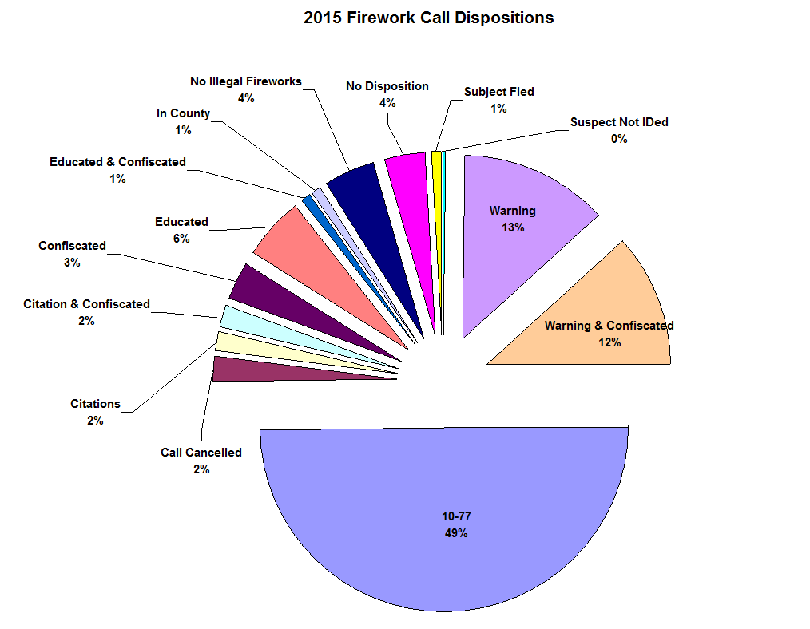A hand search was conducted of the 2015 calls to determine call disposition; and this is likely representative of other years. An overall breakdown is presented in the below chart.

A large percentage (49%) of the calls are classified as “10-77”. This indicates that the officer was not able to confirm the fireworks call. This would usually be the result of the officer being dispatched to the area after the call had been holding for some time and the reported activity was no longer taking place. The calls that do not have a disposition (4%) can be a combination of no contact, not being able to confirm the complaint, or the officers simply handling the call without taking the radio air time to inform dispatch how the call was handled.

**Recommendation**

The Lawrence Police Department could certainly make a more concerted effort to enforce the fireworks ban. This would likely require a dedication of significant resources to adequately address the volume of calls and would necessitate a deliberate refocusing of resources from other operational commitments. This may also further the “catch-22” officers are placed in when attempting to enforce the ordinance. Often, citizens point to others around them when an officer contacts them about a violation and they are quick to point out the abundance of firework stands adjacent to city streets at every main artery in and out of town. Additional public awareness and cooperation with the County on the issues could be another avenue to pursue. Location of the sale points farther away from the City or a County ban on fireworks sales may alleviate some of the confusion.